ENROLMENT FORM
For Admission of New Pupil Starting Year 20_25__

Name of Child (as on Birth Certificate):________________________________
Gender: ___________________ Date of Birth: ______________________
Home Address: _________________________________________________________________
_______________________________________________________________________________
Eircode: __________________________
Child’s PPSN: ______________________
Country of Birth: ____________________
Country of Family Origin: _____________
Language Spoken at Home: __________________________
Other relevant information:

Does your child attend/Has your child attended Playschool, Montessori or Creche?
- Yes
- No
If yes, for how many years? __________

Name and address of Playschool, Montessori or Creche:
_________________________________________________________________
_________________________________________________________________

Phone Number: ______________________

If your child is transferring from another school, please give details of previous school:
Name of School: _________________________________________________
School Address: ____________________________________________________________________ ___________________________________________________________________________________
What class was your child in? _________

Did your child access supplementary teaching through the Continuum of Support Framework? ___________

Parent 1/Guardian 1:
Name: _______________________________
Address:_______________________________________________________________________________
Email Address: ___________________________________________________
Contact Number 1: ________________________________________________
Contact Number 2: ________________________________________________
Nationality: _______________________________________________________
Parent 2/Guardian 2:
Name: _______________________________
Address:_______________________________________________________________________________
Email Address: ____________________________________________________
Contact Number 1: ________________________________________________
Contact Number 2: ________________________________________________
Nationality: _______________________________________________________

Please note the school communicates through text and email via the online platform Aladdin Connect and school email address. Our system is set up to send texts to the first parent/guardian contact information listed above. Please inform the school office in writing should you wish for texts to be sent to an alternative number.

Other Emergency Contacts:
Contact 1:
Name: ______________________________________________________
Contact Number: _____________________________________________
Description/Relationship: _______________________________________

Contact 2:
Name: ______________________________________________________
Contact Number: _____________________________________________
Description/Relationship: _______________________________________

Contact 3:
Name: ______________________________________________________
Contact Number: _____________________________________________
Description/Relationship: _______________________________________

Family:
Place in Family: _______
Please tick if your child is:
- Fostered
- Adopted
- Lives with one parent
- Has a deceased parent/stepmother/stepfather

Where applicable details of any legal orders affecting family arrangements for school.
(For example Foster Child, Ward of Court, Court Orders etc. If applicable, please provide a copy of the court order).

Health Information:
It is important that you advise us with regard to your child’s health, as the teacher may need to be aware of any medication or treatment, which he/she is receiving.
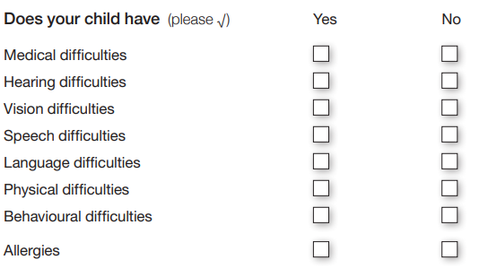
If you have answered yes to any of the health information questions, please explain:
_________________________________________________________________
_________________________________________________________________

Doctor’s Name: _________________________
Address: ________________________________________________________
Contact Number: ________________________
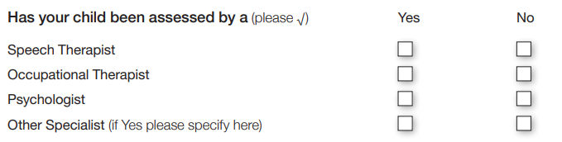
_________________________________________________________________
_________________________________________________________________
Please attach or forward any relevant reports.

Parental Consents (Please read each statement and tick the box beside it to give your consent):
I consent to my child’s photo appearing on the school website, school platforms, Aladdin Connect, school displays and local newspapers.
I consent for my contact details to be shared with the Parents Association.
I consent to my child attending school tours and outings.
I have read and agree to the school policies (accessible on the school website or upon request through the school office)
I consent to the school supplying my child’s details to the relevant Health Authorities where such information relates to providing dental care, immunisations and other health care normally provided through the school.
In the event of my child transferring to/enrolling in another school, I consent to the forwarding of all school records, reports and other relevant information to my child’s new school.
I consent to class teachers/AEN teachers to carry out any diagnostic tests necessary to support my child’s learning and educational development.
My child may participate in the SPHE programmes; Stay Safe, Walk Tall and RSE Programme.
In the case of an emergency, I give permission for my child to be taken to hospital by ambulance if such action is required.
I understand the school follows the Children’s First – Child Protection Guidelines and has a responsibility to co-operate fully with statutory agencies in issues which may involve my child.
I understand that as a condition of enrolling my child in St. Joseph’s National School, I must accept and abide by the School Code of Behaviour. I also agree to work with the school to resolve any issues relating to my child’s behaviour.

Signed: ______________________ Parent 1/Guardian 1 Date: _____________
Signed: ______________________ Parent 2/Guardian 2 Date: _____________

Please ensure you have included your child’s birth certificate, baptismal certificate (if your child is baptised) and a utility bill with proof of address with this form. These documents will be photocopied and returned to you.

GDPR and Data Protection

The General Data Protection Regulation (GDPR) came into effect on the 25th of May 2018. The GDPR applies across the European Union and aims to give individuals more rights, control and understanding of how their personal data is processed.

Under GDPR, the Department of Education is required to keep you informed of the types of data held about you and your child, the purpose it is used for, and your rights in relation to how it is processed.

The Department of Education, which provides for the education and training of people resident in the State, requires certain personal data on all learners in order to fulfil its function. For primary school pupils, the data is held on the Primary Online Database (POD). The data held on POD forms the basis of the allocation of resources to schools as well as statistical reporting on education; it is also used for research and analysis into the operation of the education system and the formation of future policies. Data is shared with the Department of Employment Affairs and Social Protection for validation purposes, and with the Central Statistics Office under Section 31of the Statistical Act for statistical reporting and analysis.

The complete Privacy Notice, which outlines further information in relation to the data held by the Department, can be found on the Department’s website at the link below, as can full details of the Department's data protection policy setting out how the Department will use your child’s data, as well as information regarding your child’s rights as a data subject.
http://www.education.ie/en/The-Department/Data-Protection/.

The information collected on this form will be held by St. Joseph’s National School in manual and electronic format. The information will be processed in accordance with the Data Protection Act, 1988, the Data Protection (Amendment) Act, 2003 and the GDPR Regulation 2018.

The purpose of holding this information is for administration needs and to facilitate the school in meeting the student’s educational needs and legal commitments etc.
Some of the data will be stored on the school’s digital platform ‘Aladdin’. We are required to share some of the information with the Department of Education, Túsla (Child and Family Agency) and the Health Service Executive.

Disclosure of any of this information to statutory bodies such as the Department of Education or its agencies will take place only in accordance with legislation or regulatory requirements. Explicit consent will be sought from Parents/Guardians, if the school requires to disclose this information to a third party for any other reason. Parents/Guardians have the right to access the personal data held on them by the school and to correct it if necessary.
I have read the above information and consent to the use of the information supplied as described.
Signed: ________________________ Parent 1/Guardian 1
Signed: ________________________ Parent 2/Guardian 2
Pupil On-line Database
The Department of Education has developed an electronic database of primary school pupils called the Primary Online Database (POD) which involves schools maintaining and returning data on pupils to the Department at individual pupil level on a live system. The database allows the Department to evaluate progress and outcomes of pupils at primary level, to validate school enrolment returns for grant payment and teacher allocation purposes, to follow up on pupils who do not make the transfer from primary to post primary level and for statistical reporting.

The database holds data on all primary school pupils including their PPSN, First Name, Surname, Name as per Birth Certificate, Mother’s Maiden Name, Address, Date of Birth, Gendre, Nationality, whether one of the pupil’s mother tongues is English or Irish, whether the pupil is in receipt of an Exemption from Irish and if so the reason for same, whether t he pupil is in receipt of Learning Support and if so the type of learning support, whether the pupil is in a Mainstream or Special Class. The database also contains, on an optional basis, information on the pupil’s religion and on their ethnic or cultural background.

Both religion and ethnic and cultural background are considered sensitive personal data categories under Data Protection Legislation. Therefore, you must identify your child’s religion and ethnic background, and consent before this information can be transferred to the Department of Education.

POD Specific Information:
To which ethnic or cultural background group does your child belong:
Categories are taken from the Census of Population. (Please tick one):

- White Irish
- Irish Traveller
- Roma
- Any other White Background
- Black African
- Any other Black Background
- Chinese
- Any other Asian Background
- Other (incl. mixed background)
- No consent

What is your child’s Religion: (Please tick one):

- Roman Catholic
- Church of Ireland (incl. Protestant)
- Presbyterian
- Methodist, Wesleyan
- Jewish
- Muslim (Islamic)
- Orthodox (Greek, Coptic, Russian)
- Apostolic or Pentecostal
- Hindu
- Buddhist
- Jehovah’s Witness
- Lutheran
- Atheist
- Baptist
- Agnostic
- Other Religions
- No Religion
- No Consent

Is one of the pupil’s mother tongues (i.e. language spoken at home) Irish or English:
- Yes
- No

I consent for POD specific information to be stored on the Primary Online Database (POD) and transferred to the Department of Education and any other primary schools my child may transfer to during the course of their time in primary school.

Signed: ____________________ Parent/Guardian Date: __________________

Signed: ____________________ Parent/Guardian Date: __________________

